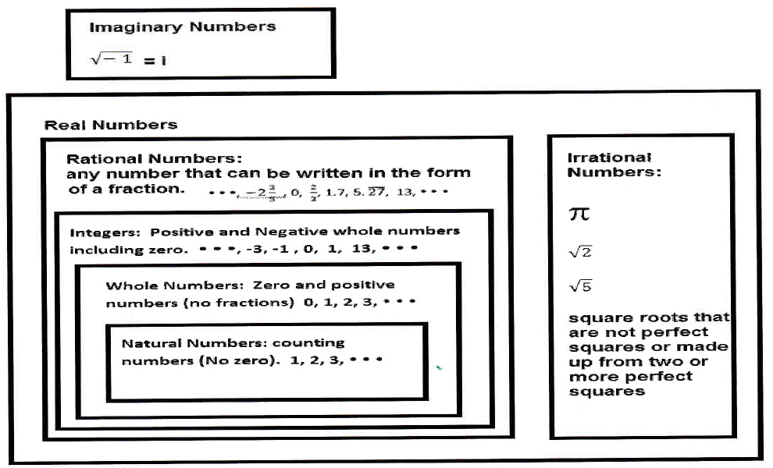Additional Classifications:

Terminating Decimal (a decimal that ends): 0.25, 125.99, 3.1675

Repeating Decimal (a decimal that has a repeating pattern of numbers): 0.333... = 0.3 0.16666... = 0.16 1.412578

Non-terminating, Non-repeating decimal ( a decimal that does not end and does not have a repeating pattern)

0.12346795824734519….